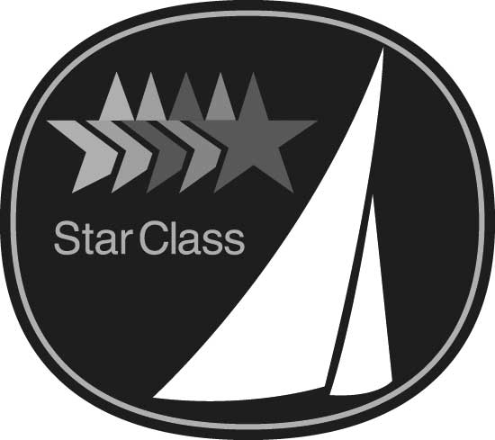
International Star Class
RESOLUTION

Resolutions for consideration at the 2023 Annual Meeting must be received at the Central Office by
May 15, 2023
Yacht Racing Association

2812 Canon Street
San Diego, CA 92106 USA
Phone +1 619 224 6998
Fax +1 619 222 0528
E-mail office@starclass.org

SUBMITTED BY:

Fleet Name:

Fleet Officer Signature: Date:

E-mail Address

PURPOSE: Amend Replace

RULE as follows:
(number and title)

OR

SPECIFICATION as follows:
(number and title)

PROPOSED TEXT:

REASON:

For Office Use Only: for Date Received:

(resolution form REV-11-14)

