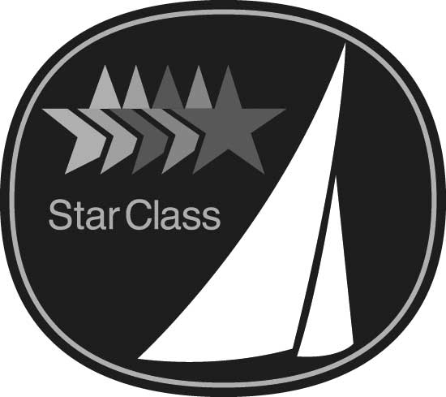
International Star Class
RESOLUTION

Resolutions for consideration at the 2025 Annual Meeting must be received at the Central Office by
9 JULY, 2025
Yacht Racing Association

2812 Canon Street
San Diego, CA 92106 USA
Phone +1 619 224-6998
Fax +1 619 222 0528
E-mail office@starclass.org

SUBMITTED BY:

Fleet Name:

Fleet Officer Signature: Date:

E-mail Address

PURPOSE: Amend Replace

11.4 as follows:
(number and title)

OR

SPECIFICATION as follows:
(number and title)

PROPOSED TEXT:

REASON:

For Office Use Only: for Date Received:

(resolution form REV-11-14)

