
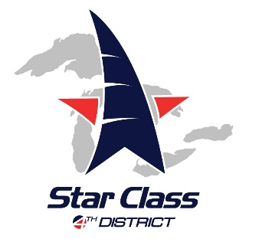

- Parkcrest Inn Motel - Harper Woods - 3.6 Stars (No tell motel)
Address: 20000 Harper Ave, Harper Woods, MI 48225
Phone:(313) 884-8800

4 miles from Crescent Sail Yacht Club

- Days Inn and Suites - Roseville - 3.4 Stars
Address: 31327 Gratiot Ave, Roseville, MI 48066
Phone:(586) 294-0400 daysinn.com
11 miles from Crescent Sail Yacht Club
- Baymont Inn & Suites - Roseville - 3.5 Stars
Address: E 13 Mile Rd, Roseville, MI 48066
Phone: (586) 296-6910 baymontinns.com
11 miles from Crescent Sail Yacht Club
- Hampton Inn - Roseville - 4.3 Stars
Address: 33680 S Gratiot, Charter Twp of Clinton, MI 48035
Phone: (586) 792-1500 hamptoninn3.hilton.com
12 miles from Crescent Sail Yacht Club
- Greektown Casino Hotel – 4.0 Stars
Address: 1200 Saint Antoine St, Detroit MI 48226
Phone: (313) 223-2999 www.greektowncasino.com

10 miles from Crescent Sail Yacht Club
- Westin Book Cadillac Hotel – 4.5 stars
Address: 1114 Washington Blvd, Detroit MI 48226
Phone: (313) 442-1620 www.bookcadillacwestin.com

11 miles from Crescent Sail Yacht Club

- Detroit Marriott at the Renaissance Center – 4 stars

Address: 400 Renaissance Drive, Detroit MI 48243
Phone: (313) 568-8000 www.marriott.com

10 miles from Crescent Sail Yacht Club

