Notice of Race

Cape Ann Star Fleet
Ned Hay Memorial Regatta
August 12, 13, 14 2022
Sandy Bay Yacht Club
Rockport, Massachusetts

The Cape Ann Star Fleet and Sandy Bay Yacht Club invite Star sailors and friends to join us for a weekend of spectacular ocean racing.
Schedule:
- Friday, August 12
-Rigging from 8:00 a.m. ‐ Park boats and trailers on T Wharf next to the Yacht Club • ------12:45 Skippers meeting, boat launching • 2:00 ‐ First warning signal, do not leave starting/racing area ‐ possible races to follow • 7:00pm - Appetizers
- Saturday, August 13
11:00 - First Race, First Gun - Lunch on boat - Do not leave starting/racing area - Multiple races to follow
6:30 cocktails and dinner

- Sunday, August 14
      - 8:30 - Coffee and Bagels, Boat Launching
      - 11:00 -First Gun, multiple races to follow. No warning signals after 14:00.
      - Awards Presentation

Governing Authorities - US Sailing and ISCYRA - Scoring: Low point

Prizes - "Ned Hay Memorial Perpetual Trophy" plus series skipper and crew (1st – 3rd) and individual race winner (skipper and crew).

Entry Fee - $175.00 incudes morning coffee and bagels, Saturday night cocktails, dinner for skipper and crew, launching fee, and prizes.

Guest Fee - $25.00 per guest for cocktail party and Saturday night dinner.

Housing: Housing will not be provided. Local inns and bed and breakfasts can be found at www.rockportusa.com.

For specific questions, contact Ken Woods:

Ken Woods
Email: kenwoods@comcast.net
Cell: (978) 985-6129

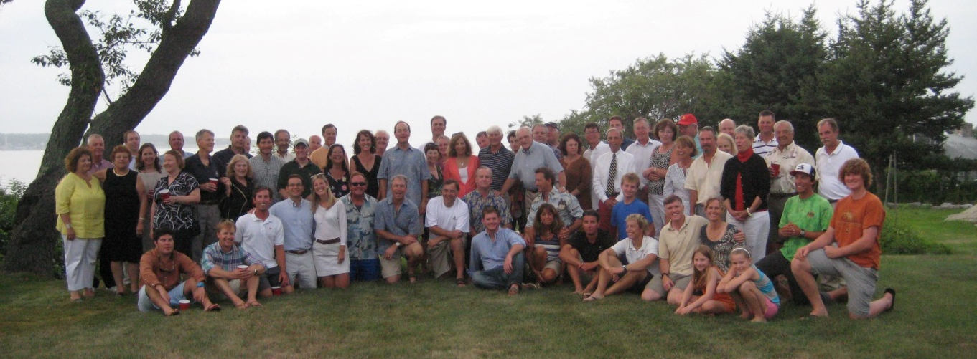
Photo: 2012 1st District Championship – Rockport, MA

We look forward to having you join us for a weekend of great sailing and fun.
-The Cape Ann Star Fleet
August 2019

2022 Ned Hay Memorial Regatta
Registration Form
Skipper: | Crew:
Address: | Phone:
Yacht #: | Yacht Name:
Yacht Color: | Fleet:
Entry Fee for Skipper and Crew | $ 175.00
Guest Fee @ $25.00 Per Guest:  Number of Guest _________ | $______________
Total Enclosed | $______________
Please Make All Checks Payable To Cape Ann Star Fleet

