OA logo

Event logo

Class logo

ISCYRA Continental Championship
Date xx/yy/zzzz

The Organizing Authority is
xyz
as sanctioned by the International Star Class Racing Association (“ISCYRA”)

NOTICE OF RACE
[NP] denotes a rule which may not be protested by another boat. This changes RRS 60.1(a) and 63.2(a).
[DP] denotes a rule for which the penalty is at the discretion of the protest committee.
[SP] denotes a rule a rule for which a Standard Penalty may be applied by the Race Committee (RC) without a hearing. This changes RRS A5.1 and A5.2

- RULES
  - The regatta will be governed by the rules as defined in The Racing Rules of Sailing (RRS).
  - The Organizing Authority (OA) is xyz as sanctioned by the International Star Class Yacht Racing Association and the Gull Lake Star Fleet.
  - Appendix P will apply. RRS P2.2 and P2.3 are deleted. RRS P2.1 will apply to all penalties.
  - No national prescriptions will apply.
  - RRS Appendix T will apply as amended in the Sailing Instructions.
  - 1.3 STCR 27.3 and STCR 34.6.2 shall apply
  - The following changes to the RRS will apply:
    - STCR 34.3.1 provides that courses will not be shortened. This changes RRS 32.
    - STCR 34.3.1 provides that course leg length may be changed within the parameters of the Format being sailed.
    - STCR 35.5 provides that the Two‐Turns Penalty is replaced by a One‐Turn Penalty. This changes RRS 44.1 and RRS P2.1.
    - STCR 34.6.3 provides that boats not finishing within the stated time after the first boat sails the course and finishes within the time limit will be scored “TLE” as defined therein (see NoR 12.4). This changes RRS 35, RRS A5, and RRS A10.
    - RRS 44.2 has been changed (see NoR para 11.2).
    - RRS 90.3(e) applies.
1.7. If there is a conflict between languages, the English text will take precedence.
1.8. To help preserve the integrity and safety of the Star Class, entries shall be open to competitors and support persons of all nationalities but not to competitors and support persons holding only Russian or Belarussian nationality. The organizing authority may amend this rule following any further World Sailing decisions on the situation with Russia and Belarus.
1.9. Each competitor at the Star xyz Championship will be required to race with a Vakaros Atlas 2 with Race Sense license. The Vakaros RaceSense system will be used during racing.
Instruction for use are shown in Attachment 4.
This system will supply OCS/Recall information among other functions. This changes and supplements RRS 29.1.
1.9(b) Failure of an Atlas 2 or the RaceSense System will not be grounds for opening a hearing regarding redress. This changes RRS 61.1(a).
1.9(c) Atlas 2 device: Competitors can rent an Atlas 2 for the period______________.
1.9(d) Each competitor is responsible for properly mounting the Vakaros Atlas 2 or Edge device according to the instructions provided in Attachment 5.
1.9(e) Competitors requiring a rental Vakaros Atlas 2 or Edge? device must submit their rental application no later than______________________.

Note to competitors:
License: Competitors who own Atlas 2 will be required to acquire a license.
ll an Atlas 2 is rented, the Atlas 2 comes with a license.
Vakaros contact: Support@vakaros.com
- [NP] SAILING INSTRUCTIONS
  - The SIs will be available on the ONB no later than 12:00 xyz, on mo/day/year.

- [NP][DP] COMMUNICATION
  - The official notice board is located online at link to RRoS ONB
  - As a courtesy, WhatsApp will be used to repeat regatta information.
  - Courtesy copies of notices and documents from the Official Notice Board may be posted on a physical notice board located at xxxxxxx. Failure to post will not be grounds for redress. This changes RRS 61.1(a).
  - Boats shall carry VHF radios capable of transmitting and receiving on international VHF frequencies for purposes of safety and for receiving race committee communication
  - Failure of any information to be given or received shall not be grounds for redress. Information gathered on any other VHF channel or RC communication channel shall not be grounds for redress, except when a request for redress under this instruction is initiated by the RC or the Jury. This changes RRS 61.1(a).
  - From the first warning signal until she has finished her last race of the day, except in an emergency, a boat shall not make voice or data transmissions and shall not receive voice or data communication that is not available to all boats

- 4.[NP][DP] ELIGIBILITY AND ENTRY
4.1 Eligibility:
4.1.1 STCR 26.1 Provides that entries are open to all active, life, and isolated skippers.
4.1.2 Crews must comply with STCR 26.2.
4.1.3 Boats must comply with STCR 21.
  - Eligible boats may enter by completing the on-line application prior to mo/day/year. CLICK HERE TO GO TO THE ON LINE APPLICATION. Entries received after mo/day/year will be subject to a $100 late fee. Entries after mo/day/year must be approved by ISCYRA.
  - Entries will be limited to xxx boats.
  - Only skippers and crew eligible to compete under the WS Eligibility Code are to compete in this regatta.
  - Individual and support/coach vessels shall register in advance and check in with the OA during registration at the regatta registration desk and shall comply with all applicable event documents, RRS, and STCRs.
  - Only boats/competitors that have met the following conditions prior to mo/day/year, may compete:
(a) All fees are paid;
(b) Equipment measurement, inspection, and crew weight-in are completed; and
(c) Proof of insurance is provided.

- [NP] FEES
5.1 The entry fee is xyz. The entry fee for U30 teams is discounted to 50% of the regular entry fee . No Star Class fee will be collected on U30 teams. The fee includes the Star Class fee, boat and trailer parking, launching, hauling, and invitations to social events for skipper and crew.
5.2 Entry fees are due at the time of entry but not later than midnight (xyT) on dd:mm:yyyy, and payable via credit card on the website checkout form.
5.3 The late entry fee of xyz will be assessed entries received after mo/day/year, given conformance to NoR
5.4 Entry fees will be refundable per following:
- Full refund of entry only if cancelled prior to the close of entries
- 50% if canceled in the first 14 days following the close of entries.
- No refunds if cancelled more than 14 days from the close of entries.
- Full entry fee will be refunded if the entry is rejected.
5.5 The support vessel fee will be $150 and is Non-refundable. This includes dd:mm:yyyy to dd:mm:yyyy, on- premises parking for trailers, berthing for coach vessels, use of the crane, and support vessel ID flag.

- Other fees
6.1 Food voucher for each accompanying Support Person or other guests xyz payable at registration. Other charges are payable by credit card as incurred.

- [NP][DP] ADVERTISING
  - Competitor advertising will be in accordance with the World Sailing Advertising Code.
  - Boats may be required to display advertising and/or bow numbers chosen and supplied by the organizing authority. See Attachment 3 for positioning of bow numbers and event advertisement.

- [NP] Schedule
  - As per STCR six (6) races are scheduled.
  - As per STCT 27.1 one (1) race is scheduled each day. The RC reserves the right to get one race ahead of schedule should expected sailing conditions warrant.
  - As per STCR 34.3.9 the RC may change the schedule. No more than two races per day may be sailed, per the format being sailed.
  - To alert boats that a race will begin soon, the orange starting line flags will be displayed with one sound at least five minutes before a warning signal is made.
8.5 Racing:

Wednesday, mo/day/year
10.00 – 17.30 hrs. Registration, Inspection of boats, Sail check; Team Weigh-In
14.00 hrs. Practice Race

Thursday, mo/day/year
11.00 Warning Signal-2 races scheduled

Friday, mo/day/year
11.00 First Warning Signal-2 races scheduled

Saturday, mo/day/year
11.00 Warning Signal-2 races scheduled

Sunday, mo/day/year
Any races necessary to complete series.
10.00 hrs. Warning Signal

1400 hrs. latest time for Warning Signal

8.6 SOCIAL:

Wednesday mo/day/year
17.00hrs. Opening Ceremony, Cocktail Party, xyz location (Blazers).

Thursday, mo/day/year
15.00hrs. Social after racing. Xyz location

Friday, mo/day/year
15.00 Social after racing, GLYC Pavillion.
18.00 Century Celebration/Dinner, xyz location

Saturday, mo/day/year

17:00 Prize Giving, xyz location (Blazer)

- [NP] MEASUREMENT
  - Each boat shall have a valid measurement certificate. In addition, equipment required by STCR 31.2.2 will be inspected.
  - Not more than two mainsails and two jibs shall be measured. Sail royalty button numbers shall be recorded for the permitted two mainsails and two jibs.
  - Teams shall demonstrate compliance with team weight limits in accordance with STCR 31.1.3 prior to the end of inspection. Teams will not be subject to reweighing during the regatta, subject to the exception in STCR 31.1.3.
  - Boats may be inspected at any time.

- VENUE
  - Attachment 1 shows the location of the regatta harbor and racing area.

- THE COURSES
11.1 The courses to be sailed will be in accordance with STCR 34.3. See Attachement 2.

- [NP] PENALTY SYSTEM
  - Decisions of the international jury will be final, as provided in RRS 70.5.
  - In RRS 44.2 insert after the first sentence:
“However, if Mark 1a is a mark of the course, a boat may delay taking a penalty for an incident:
(i) in the zone around Mark 1 or
(ii) on the leg between Mark 1 and Mark 1a,
until she has passed Mark 1a”

- [NP] SCORING
  - The scoring system is the Low Point System in RRS Appendix A.
  - As per STCR 27.1, four (4) races are required to be completed to constitute a series.
  - When fewer than five (5) races have been completed, a boat’s series score will be the total of her race scores.
  - When five (5) or more races have been completed, a boat’s series score will be the total of her race scores, excluding her worst score. This changes RRS A2.
  - A boat scored TLE receives points equal to the number of boats that finished the race plus one.
This changes RRS 35, RRS A5, and RRS A10.

- [DP] [NP] SUPPORT PERSON / VESSELS
  - Per STCR 31.1.4, boats shall receive no outside assistance from any Support Vessels and or Support Persons, including towing, once she has left the dock for the day and until she finishes her last race of the day, except in the case of emergency and/or towing directed by/supplied by the OA and available to all participants.
  - Support vessels shall be marked with a flag given to them at Registration.
  - Per RRS 37, Support Vessels and persons shall carry a functioning international VHF (See NoR 3.4) and monitor the required channel and shall assist the race committee as requested.
  - The Sailing Instructions and/or the OA may further limit the activities of the support vessels.
  - All Support Vessels shall be equipped with a functioning engine safety cut-out switch (kill switch), which shall remain attached to the person at the helm at all times while the engine is running. Failure to comply may be misconduct and/or result in expulsion from the event.

- [NP][DP] BERTHING
  - Boats shall be kept in their assigned places in the boat park or when berthed in the harbor while afloat.

- [NP][DP] HAUL-OUT RESTRICTIONS
  - There shall be no haul out restrictions.

- [NP] RISK STATEMENT
  - RRS 3 states: ‘The responsibility for a boat’s decision to participate in a race or to continue to race is hers alone.’ By participating in this event, each competitor agrees and acknowledges that sailing is a potentially dangerous activity with inherent risks. These risks include strong winds and rough seas, sudden changes in weather, failure of equipment, boat handling errors, poor seamanship by other boats, loss of balance on an unstable platform, and fatigue resulting in increased risk of injury. Inherent in the sport of sailing is the risk of permanent, catastrophic injury or death by drowning, trauma, hypothermia, or other causes.

- [NP]INSURANCE
  - Each participating boat shall be insured with valid third-party liability insurance for racing risks with a minimum cover of $100,000 (3MEU in Europe) per incident or the equivalent.
  - Each participating support boat shall be insured with valid third-party liability insurance with a minimum cover of $300,000 (3MEU in Europe) per incident or the equivalent.
  - The OA is not responsible for verifying the status or validity of insurance

- [NP] PRIZES
19.1 The Sir Durward Knowles Trophy awarded to the 1st place skipper

19.2 The Dona Chiarella Trophy awarded to the 1st place crew.

19.3 Daily award for 1st place and Gailliard Trophy for 1st place in the last race of the regatta.

19.4 First through Third Place for the Regatta.

19.5 First Place Skipper Under 30

19.6 The OA reserves the right to award additional prizes at its sole discretion.

- DISCLAIMER OF LIABILITY
  - Competitors participate in the regatta entirely at their own risk. See RRS 3, Decision to Race. The organizing authority will not accept any liability for material damage or personal injury, or death sustained in conjunction with or prior to, during, or after the regatta.

- [NP] MEDIA RIGHTS
  - Skippers and competitors automatically grant to the OA and their sponsors, without payment, the right in perpetuity to make, use, and show any motion pictures, still pictures, and live, taped, or filmed television of or relating to the event, where their image or name may appear.
  - Boats may be required to carry cameras, sound equipment, and positioning/tracking equipment as specified and supplied by the Organizing Authority board while racing.

22. FURTHER INFORMATION CONTACTS

Key Contacts

23 OTHER INFORMATION NOT PART OF THE NoR

23.1 Name and Address of OA. Bar/restaurant charging terms

23.2 Housing

Explore Airbnb and VRBO for other good options.

23.3. Airports

Attachment 1 – Racing Area

Attachment 2 Courses

34.3.2. Course 0.
An isosceles right-angled triangle, followed by a windward and return, and finishing on a final windward leg, the right-angle mark being omitted after the first round.
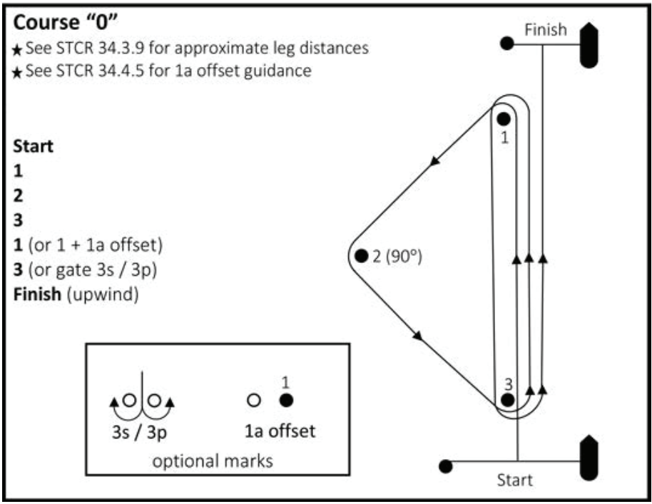

34.3.3. Course 1.
An isosceles right-angled triangle, followed by a windward and return, the right-angle mark being omitted after the first round.
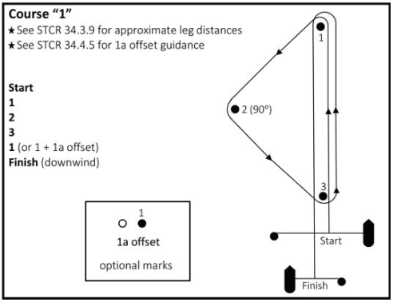

34.3.5. Course 3.
Two complete right-angled triangles, with the hypotenuse the third leg, followed by a final windward leg (7 legs). The triangle is intended to be basically a windward-leeward circuit, with the second leg consisting of a reach of approximately 55 meters at right angles to the direction of the first leg.
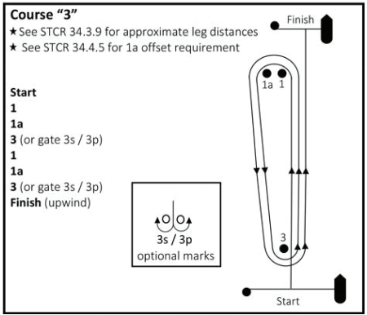

34.3.6. Course 4.
Two complete right-angled triangles, with the hypotenuse the third leg (6 legs), finishing downwind. The triangle is intended to be basically a windward-leeward circuit, with the second leg consisting of a reach of approximately 55 meters at right angles to the direction of the first leg.
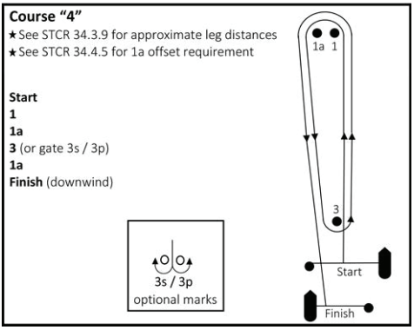
1
1a
Finish (downwind)

34.3.7 Course 6.
Two complete right angled isosceles triangles, with the hypotenuse being legs 1 and 4, finishing at the end of leg 6
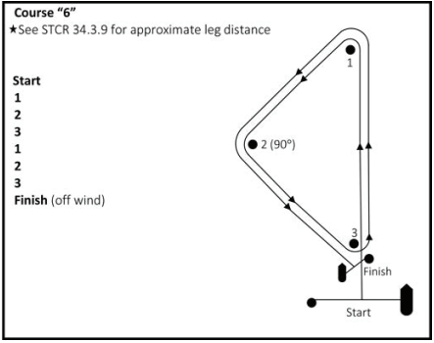

34.3.8 Course 7.
Two complete right angled isosceles triangles, with the hypotenuse being legs 1, 4 and 7, finishing at the end of leg 7.
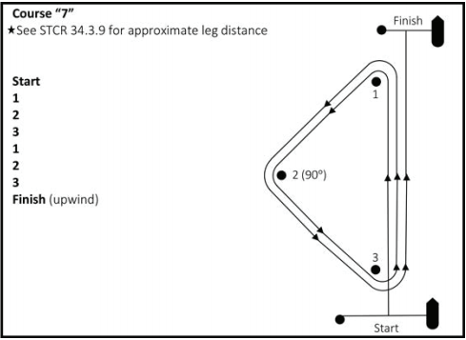

Attachment 3
Bow number and advertising stickers diagram

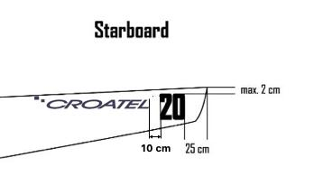
Attachment 4

[NP] Rules and Instructions for Using the Vakaros and RaceSense System

1. The Vakaros RaceSense system will be used by the Race Committee (RC), and the relevant information will be available to all boats. As defined in RRS 41 (c).

2. Instructions for using the electronic Atlas 2 / Atlas Edge device will be posted on the Official Notice Board.

3. Competitors shall take all reasonable measures to keep the Atlas 2 / Atlas Edge safe and operational and promptly notify Vakaros staff on the water or ashore of any device issues.

4. RRS 26 is changed. The countdown to the start on the Atlas 2 / Atlas Edge from RaceSense will be the official time. Signal flags will only be used for information purposes.

5. The visual identification of boats infringing RRS 29 and RRS 30 by the RC is replaced with electronic identification through the Vakaros RaceSense system, modifying RRS 29.1, 30.1, 30.2, 30.3, and 30.4.

6. In the event a start needs to be postponed, for fairness or safety reasons, the RC will display code flag “AP”.

7. Any failure of the Atlas 2 / Atlas Edge, RaceSense system, or communication systems will not constitute grounds to
request redress by a boat. This changes RRS 61.1(a).

8. If the RC vessel displays flag O with a sound signal before the warning signal of a race, rules 4. and 5. in this Addendum
will not apply to that race. The Race will be started using RRS 26.

9. If the RC vessel displays flag R with a sound signal before the warning signal of a race, all Competitors shall restart their
Vakaros Atlas 2 / Atlas Edge unit by switching it off, waiting 10 seconds, and then switching it back on to reconnect to the RaceSense network. Flag R will remain displayed for a minimum of 2 minutes and will be removed with the next warning signal.

10. If firmware updates to Atlas 2 / Atlas Edge devices are required between scheduled race days, notice will be sent to all
competitors via email or SMS/ and or the Regatta WhatsApp group and or the ONB.

Attachment 5

[NP]Atlas 2 mounting specifications

An Atlas 2 is required equipment for the 2025 World Championship. Whether owned or rented (see rental opportunity on class website), the Atlas 2 shall be mounted conforming to the following specifications, which shall be checked during measurement and may be verified at any time during the championship.

The Atlas 2 shall be:
- Mounted on the centerline of the boat
- Mounted 2385mm +-25mm aft of the intersection of the jib stay (headstay) and the deck.
- Mounted with the display facing aft, perpendicular to the centerline
- Mounted with a minimum of 150 mm clearance to the mast
- No conductive materials may be within 25mm of the top of the Atlas 2. Only nonconductive materials (e.g., plastic and fiberglass) are permitted in this region.

